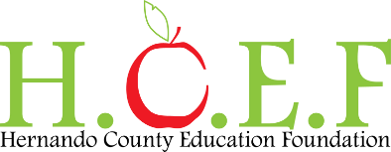
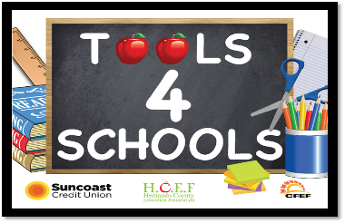

Free School Supplies!

Parents, if you are needing school supplies, the Hernando County Education Foundation will be giving out school supplies on the following dates at the following locations. This will be on a first come, first serve basis. We will be there until we run out.

Brooksville Elementary School
11:00-1:00 (or until supplies last)
Thursday, April 16th

Spring Hill Elementary
11:00-1:00 (or until supplies last)
Thursday, April 23rd

Some of the items pre-packed may include: notebook paper, pencils, pens, rulers, markers, crayons, colored pencils, poster board, erasers, glue bottles, composition notebooks, etc.

ALL supplies have been donated through the free Tools 4 Schools Teacher Supply store!

Thank you Suncoast Credit Union for supporting our teachers and students in Hernando County!

