Hernando County Sheriff’s Office
Youth Education Services

RICHARD BUCKINGHAM
2021 COMMUNITY SERVICE SCHOLARSHIP
APPLICATION

Scholarship Goal:
(This scholarship is NOT for persons pursuing a career in Public Service, Law Enforcement or Fire Service)
To grant a high-impact scholarship to enable a person to obtain an education (2-year, 4-year, technical, or trade school) that they may not be able to do on their own or with the means at hand.

Scholarship Terms:

- This scholarship is only open to Hernando County High School Seniors.
- This is a competitive scholarship, not all applicants will receive funding.
• This scholarship will weigh applications based on demonstrated need, program of study, as well as the other information requested in the application.
• This scholarship may be applied to a new enrollment or to allow a student to complete a program already in progress.
• Only one scholarship per year per candidate will be awarded.

Application Requirements:

• Completed applications containing all information must be returned to no later than March 31, 2021

Application must contain:

• A copy of your official transcript;

• Two (2) current letters of recommendation from teachers, advisors or organization that you volunteered with;

• A brief (no more than 2 pages) autobiography to include your reasons for applying for this scholarship, any work experience, your proposed field of study and future career plans; your interests, and any leadership positions you have held.

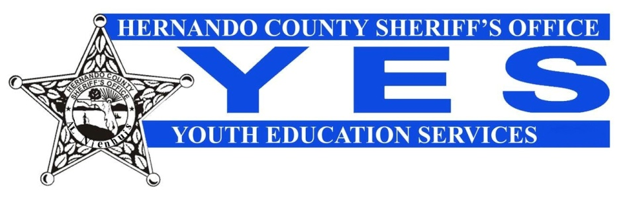
RICHARD BUCKINGHAM
COMMUNITY SERVICE SCHOLARSHIP 2021
APPLICATION
NAME:
Last First Middle Initial

ADDRESS:
Street City State & Zip

PARENTS/GUARDIANS:

PARENTS/GUARDIANS OCCUPATION:

PHONE:
(Area Code)

DATE OF BIRTH: AGE:

CURRENT HIGH SCHOOL: GPA:

VOLUNTEER SERVICE INFORMATION: (You may attach resume instead)

Name of organization Supervisor # hours to date
or school affiliated program

-Page 1 of 2-
Richard Buckingham Community Service Scholarship Page 2

Where do you plan to continue your education after high school:
College/University
Community College
Trade School

Other

Scholarship is open to all career fields: Please note what major you will pursue?

IMPORTANT: Along with your application you will need:

- A copy of your official transcript;
- Two (2) current letters of recommendation from teachers, advisors or organization that you volunteered with;
- A brief (no more than 2 pages) autobiography to include your reasons for applying for this scholarship, any work experience, your proposed field of study and future career plans; your interests, and any leadership positions you have held.

All applications must be received at the Sheriff’s Office by 5:00 p.m. on Friday, March 31, 2021.* Bring application to 18900 Cortez Blvd. or mail to the Hernando County Sheriff’s Office, P.O. Box 10070, Brooksville, FL 34603 (Attn: Youth Education Services)

Receipt of applications will not be acknowledged. The Youth Education Services Selection Committee will determine the scholarship recipient. The recipient will be notified by the Committee and a check will be sent to an accredited institution for deposit to the student’s account.

Applicant’s Signature Date

Signature of Parent/Guardian Date

*Applications will not be accepted after March 31, 2021.

