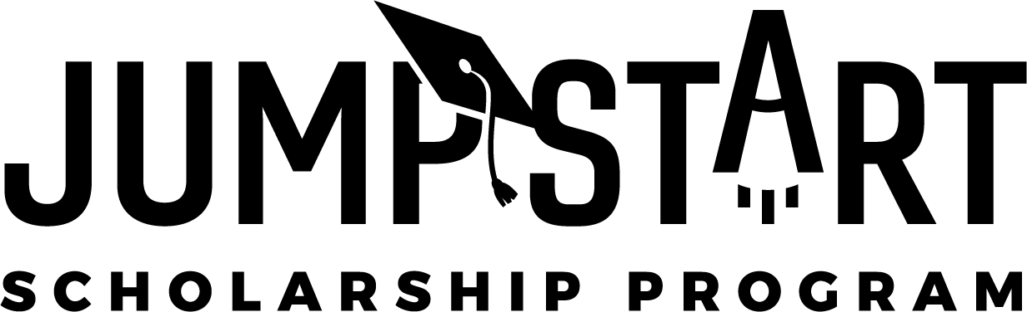
You Can Help Local Students Launch Their Future
Two of every three new jobs created in Florida by 2025 will require education or training beyond high school.
Today’s students need higher education to adapt and thrive in our changing economic landscape.
Fast-track technical or vocational certificate programs can launch students into many high-demand careers. For other eligible students, we have an opportunity to get them on a two- or four-year post-secondary path with a remarkable, highly flexible scholarship opportunity that covers a full year of Florida college tuition for a fraction of the value.
The Consortium of Florida Education Foundations and the Florida Prepaid College Foundation are creating a pathway for deserving high school seniors to jump start their future through local education foundation sponsored need-based scholarships for post-secondary education.
Each Jump Start scholarship provides recipients:
• 30 credit hours of tuition at a Florida state public college or the equivalent value at Florida public universities and technical colleges for eligible credit-hour programs.
• Support for college success, including financial aid, life skills and career exploration workshops.
By becoming a Jump Start sponsor, your organization can purchase scholarships worth $3,000 each at a fraction of their value and provide life-changing opportunities to promising local high school seniors while contributing to the overall economic future of your community.
A PROGRAM OF
