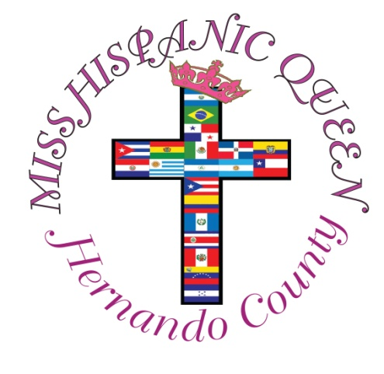
2024

NAME_____________________________LAST NAME__________________________
PARENT/GUARDIAN________________________________#______________________
ADDRESS______________________________________________________________
AGE______DOB_____________GRADE_________Cell #_____________________________
LATIN ORIGIN _____________________SCHOOL____________________________________
PRIZE: Crown, Sash, Scholarship and participation in Multicultural Parade
Participant does not need to be fluent in Spanish – FREE REGISTRATION

Thank You for your interest in participating. You must be a resident of Hernando or Pasco County attending school, not married, no children, meet age requirements and be of Hispanic heritage. This is a cultural event and not a beauty pageant. Candidates will be announced on social media and by signing registration you consent to use your photos from events for publication prior to event, during and after. For questions, please call or text Vivian Rivera 352-346-3531.

Preparation for event is mandatory and would be twice leading up to gala night, September 14, 2024, for approximately 1 hour. Location and day will be given to you prior to start date. If we feel additional time is needed to better prepare for the presentation, we will let you know in advance.

Workshops are on culture, traditions, heritage, catwalk, poise and on interview preparation and event presentation.

To allow candidates to feel less pressure and be more comfortable we ask parents to please wait outside of meeting area. If you leave, please be on time picking up your child.

A set of rules will be provided to each participant and parents for review and signature.

Applicant’s Signature_______________________________Date______________
Parent’s Signature________________________________ Date_____________

