S P O N S O R S H II P F O R M
Aim 4 Education to support local schools, teachers and students.
Breakfast - Lunch - Awards Ceremony - Silent Auctions - Swag Bags
Tampa Bay Sporting Clays 10514 Ehren Cutoff, Land O' Lakes, FL 34639
Saturday, May 18, 2024 ~ 8:00 a.m. - 1:30 p.m.

Business Name: Contact Name: Mailing Address: Phone: Email: For recognition purposes, list this sponsor as:
My company would like to provide items for swag bags Yes or No (Please provide 100 items for the bags)
Description of item:

Diamond Sponsor $10,000
Eight teams of 4, including 8 carts - includes breakfast/lunch Logo Listed as Presenting Sponsor with Event Logo Participation in Awards Ceremony
Mentioned in All press releases and Radio Promotion Promotion on Social Media
Logo and Link listed on HCEF event website Logo on Swag Bag Given to Participants Items to Include in Swag Bags
Premier Display Table at Event
Large Company Banners Displayed at event Full Page AD in Event Program
Logo on All Yard Signs at Event
Large Logo listed on Event Thank You Banner
Listed on HCEF Business Partner Page w/ Sponsorship Value

Gold Sponsor $5,000
Four teams of 4, including 4 carts - includes breakfast/lunch Mentioned in All press releases & Radio Promotion
Logo and Link listed on HCEF event website
Promotion on Social Media

Bronze Sponsor $1,000
One team of 4, including 1 cart includes breakfast/lunch Promotion on Social Media
Items to Include in Swag Bags Display Table at Event
Logo listed in Event Program Logo on 2 Yard Signs at Event
Small Logo listed on Event Thank You Banner
Listed on HCEF Business Partner Page w/ Sponsorship Value

Copper Sponsor $500
Logo listed on HCEF event website Promotion on Social Media - Name Listed in Event Program Display Table at Event-
Items to Include in Swag Bags
(2) Breakfast/Lunch Tickets
Listed on HCEF Business Partner Page w/ Sponsorship Value

Sign Sponsor $150
Yard Sign placement at event

Items to Include in Swag Bags endor Table $25/ $50

Display Table at Event
Medium Company Banner Displayed at event Half Page AD in Event Program
Logo on 6 Yard Signs at Event
Medium Logo listed on Event Thank You Banner
Listed on HCEF Business Partner Page w/ Sponsorship Value

Silver Sponsor $2,500
Two teams of 4, including 2 carts - includes breakfast/lunch Mentioned in All press releases & Radio Promotion
$25 with Silent Auction Donation / $50 without Silent Auction Donation Vendor Table Space At Event
Promotion on Social Media Items to Include in Swag Bags

Team Entry $575
One team of 4, including 1 cart - includes breakfast/lunch

Individual Entry $160
One team of 4, including 1 cart - includes breakfast/lunch

Promotion on Social Media Lunch Patron $25

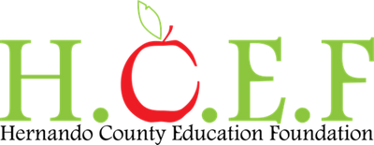
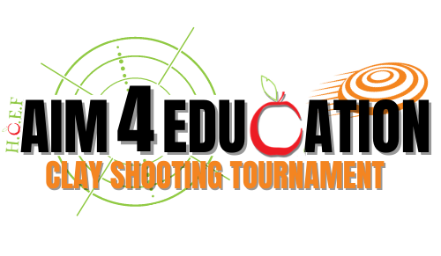
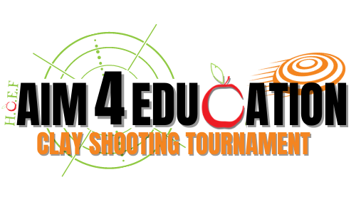
Small Logo included in Picture Backdrop for Event Items to Include in Swag Bags
Payment Information
My check is enclosed and payable to HCEF.
Check # Total $
I will call the HCEF at (352) 797-7313 ext 0 with my credit card information - Total $
OR
Payable at www.hernandoeducationfoundation.org
OR
I cannot sponsor but would like to donate a gift of $
Mail form and payment to: 900 Emerson Rd Brooksville, FL 34601 For questions, please call (352) 797-7313 ext 0
OR
Small Logo listed on Event Thank You Banner
Listed on HCEF Business Partner Page w/ Sponsorship Value

Food Sponsor $2,000
Corporate sponsor recognition at Breakfast and Lunch area Promotion on Social Media
Logo and Link listed on HCEF event website Program recognition
Logo on Yard Signs at Event Items to Include in Swag Bags
Please email logo & form to HernandoEducation@gmail.com
Display Table at Event
Small Company Banner Displayed at event Quarter Page Ad in Event Program
Logo on 4 Yard Signs at Event
Lunch for Non-Participant Attendee / Spectator

Lunch Menu
Pulled Pork, Chicken, Pork Ribs
Mac n Cheese, Baked Beans, Potato Salad, Dinner Roll Ice Tea and Lemonade

