h
Michael A. Pikos, DDS
Nicole Hernandez, DDS, MD
Othman Rezki, DMD
Diplomates: American Board of Oral 1111and Maxillofacial Surgery
Board Eligible*
Lindsey Pikos Rosati, DDS, MS
Anthony M. Pikos, DMD, MS
Bashar Adeinat, DDS, MS
Diplomates: American Board
of Periodontology
Innovative Care
- Same Day Teeth®
A revolutionary protocol for dental implants
- State-of-the-art dental implant technology; bone & soft tissue grafting
- Cone beam computed tomography (CT scan)
- Digitally guided bone augmentation (DGBA™)
- Wisdom teeth & general tooth extraction
- Pre-orthodontic care

- Periodontal plastic surgery.
therapy

- General anesthesia, nitrous
oxide & local anesthesia

2711 Tampa Road
Palm Harbor, FL 34684
Tel: 727-786-1631
Fax: 727-785-8477
PHoffice@CoastalJaw.com

8740 Mitchell Boulevard
Trinity, FL 34655
Tel: 727-877-0011
Fax: 727-807-6033
SDToffice@CoastalJaw.com

8845 Hawbuck Street
Trinity, FL 34655
Tel: 727-375-0469
Fax: 727-375-0496
Trinityoffice@CoastalJaw.com

4372 Commercial Way Spring Hill, FL 34606
Tel: 352-596-6804
Fax: 352-596-3615
SHoffice@CoastalJaw.com
11940 Sheldon Road
Tampa, FL 33626
Tel: 727-375-0469
Fax: 727-807-6033
Tampaoffice@CoastalJaw.com
3003 Enterprise Road East
Clearwater, FL 33759
Tel: 727-799-4492
Fax: 727-724-8963
Clearwateroffice@CoastalJaw.com

www.CoastalJaw.com
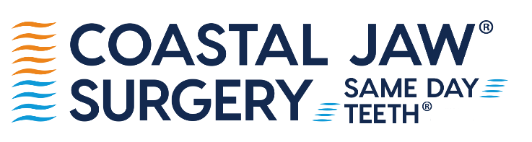

February 16, 2026

Dear Scholarship Applicant,

Thank you for your interest in the Coastal Jaw Surgery Scholarship Program. The purpose of our scholarship is to grant a $1,000 scholarship to a graduating senior. This year, two total scholarships will be given to the winners across Hernando, Hillsborough, Pasco, and Pinellas counties. As an applicant, you must plan on pursuing a career within the healthcare field.

To apply, please follow these instructions:

- Complete the scholarship application
- Compose a 250-word essay about your career aspirations and why you are a worthy recipient of this scholarship
- Attach three letters of recommendation
- Attach a copy of your transcripts
- Attach a recent photo

Return all portions by email to marketing@coastaljaw.com or by mail to Coastal Jaw Surgery Scholarship Committee, 8740 Mitchell Blvd, Trinity, FL 34655. The deadline for submitting your fully completed application is Friday, April 24, 2026.

Coastal Jaw Surgery is a surgical based, multi-specialty dental practice, offering comprehensive oral healthcare services including Same Day Teeth®, traditional dental implants, oral surgery, prosthodontics, and periodontal services. Our doctors are offering this scholarship program as part of our continuing effort to focus on the education needs of the public and other healthcare professionals.

We would like to take this opportunity to wish you great success in your future endeavors.

Best,

Stacey Fink

Stacey Fink
Marketing Manager

staceyf@coastaljaw.com

